Asia-China-Coin-Bridge-Dragon-Mould

weight:144g

size : leight 9.5 cm*width 4.5cm

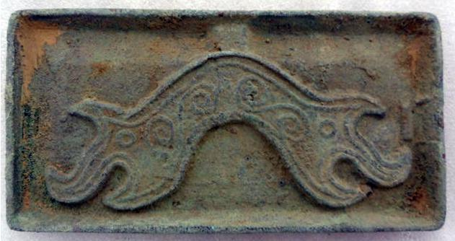 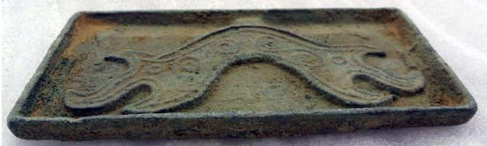 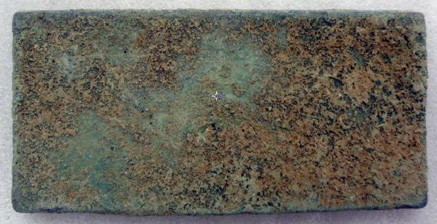

# Oriental Asian Chinese bronze pattern tools of the trade bridge mould,classical

### Seller information

|  |  |
| --- | --- |
|  |  |

[lengxue](http://myworld.ebay.com/lengxue?_trksid=p2047675.l2559) ([27](http://feedback.ebay.com/ws/eBayISAPI.dll?ViewFeedback&userid=lengxue&iid=141151173787&ssPageName=VIP:feedback&ftab=FeedbackAsSeller&rt=nc&_trksid=p2047675.l2560) ) 

100% Positive feedback

[Follow this seller](http://www.ebay.com/itm/141151173787)

[See other items](http://www.ebay.com/sch/lengxue/m.html?item=141151173787&rt=nc&_trksid=p2047675.l2562)

Top of Form

## Item Information

Item condition:

--not specified

“ancient coin mould”

Ended:

Dec 28, 2013 03:48:44 PST

Sold for:

US $9.99

|  |  |  |  |
| --- | --- | --- | --- |
|  | Join **eBay Bucks** and earn **%** back on this item. [See conditionsfor eBay Bucks - opens in a new window or tab](http://pages.ebay.com/rewards/terms.html?ssPageName=STRK:VI:LNLK:TCS) | |  |
|  | | New customers get $10 back on 1st purchase Subject to credit approval.[See terms](https://apply.billmelater.com/apply?guid=1SJ8TEIO&assetId=NBRVI1213) | |

Shipping:

$10.00 ePacket delivery from China | [See details](http://www.ebay.com/itm/141151173787" \l "shpCntId)

Bottom of Form